## Create the Base Roads

1. Select the Road tool from the Road Tools tab and draw an east west road. Change it to four lanes
2. With the Road tool already in use, draw a north south road that intersects the 4-lane road and change it to a 3-lane road as shown.

* 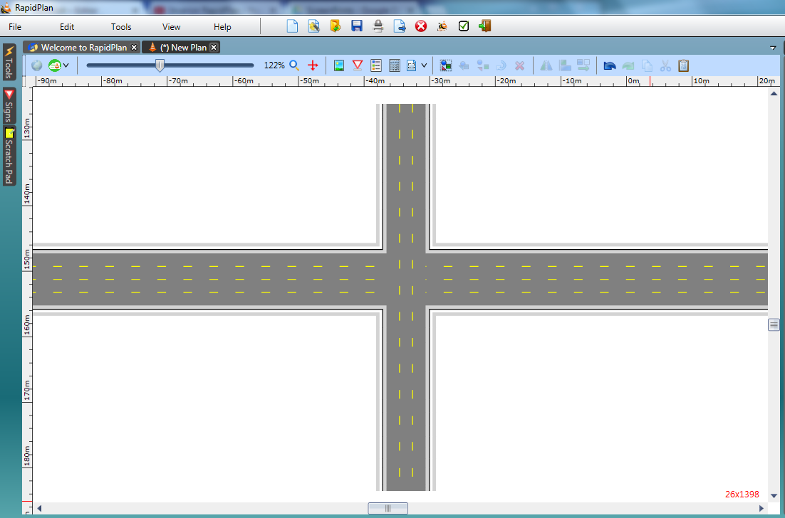
* Crossroad_Intersection_step_1_and_2